**Set-up for zoom bot**

Go to marketplace.zoom.us

Create your account

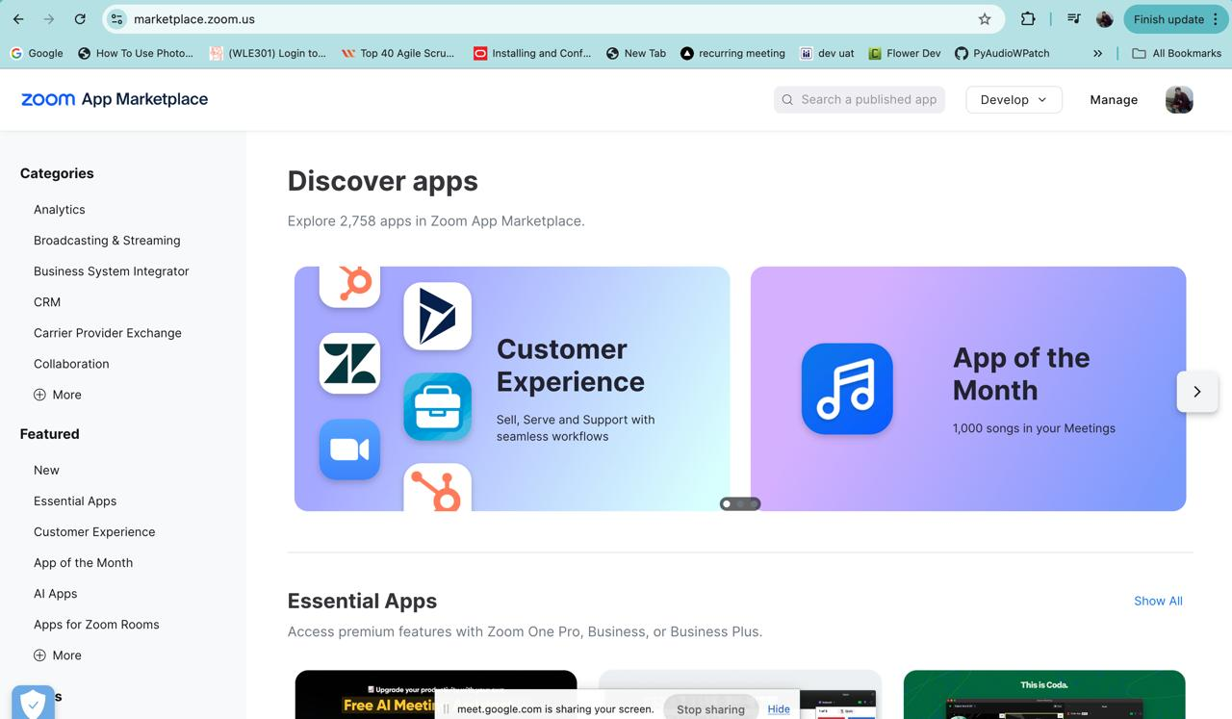

Click on general app

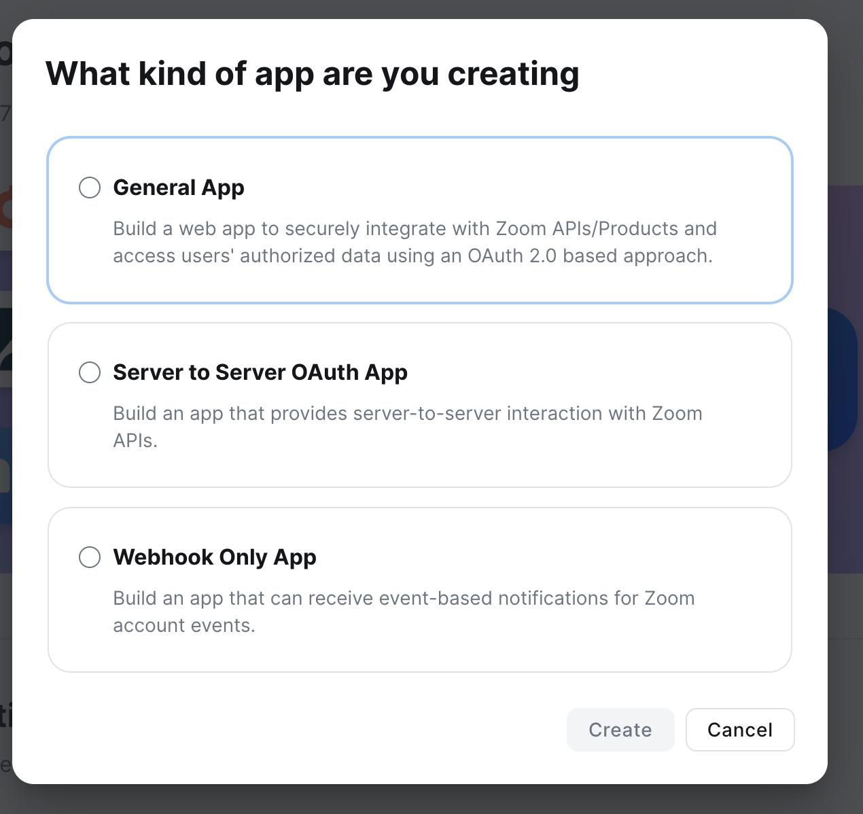

After that you will get client id and client secret key

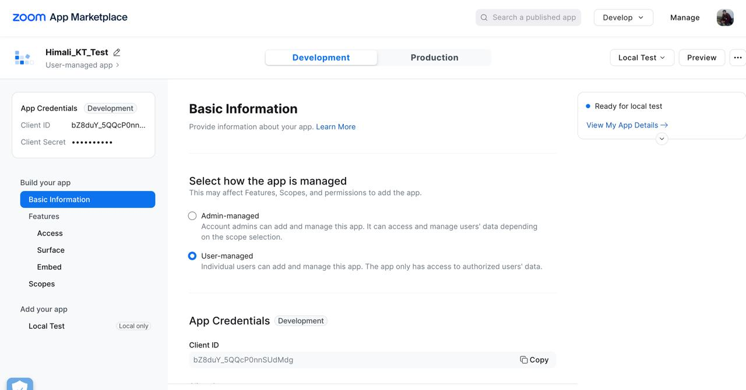

Go to basic information on left side panel and select user- managed option

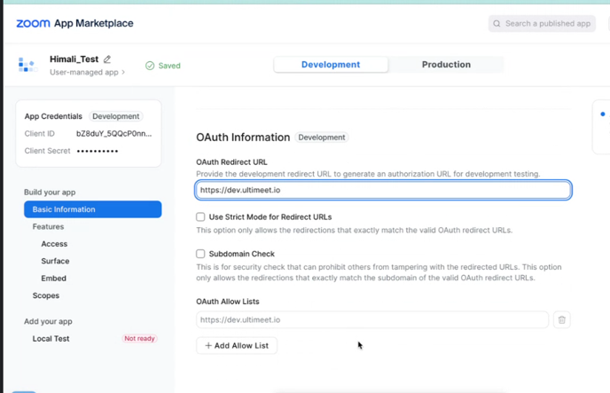

**In Oauth redirect URL**

**Write** [**https://dev.ultimeet.io**](https://dev.ultimeet.io)

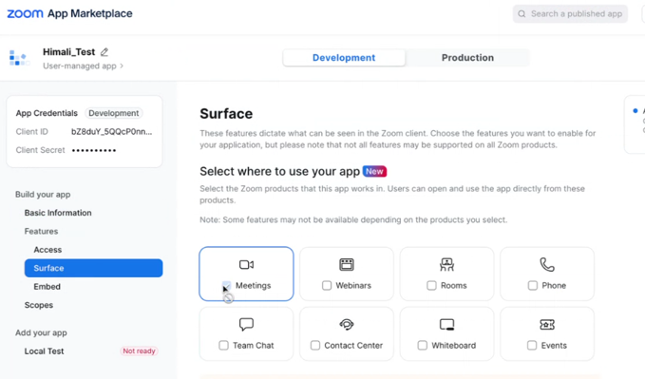

**Go to surface tab and select meetings**

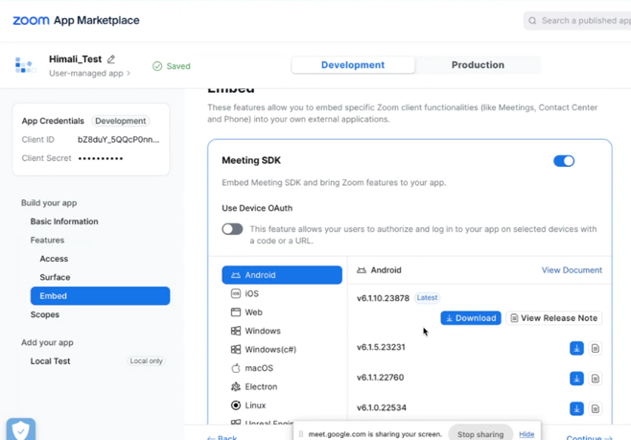

**Go to embed and select Linux and click on download button. So, you will get sdk file for zoom bot.**

**After that run docker**

**Go to the folder where these files are located.**

**Run command in terminal**

**->docker compose up**

**After that go to Docker**

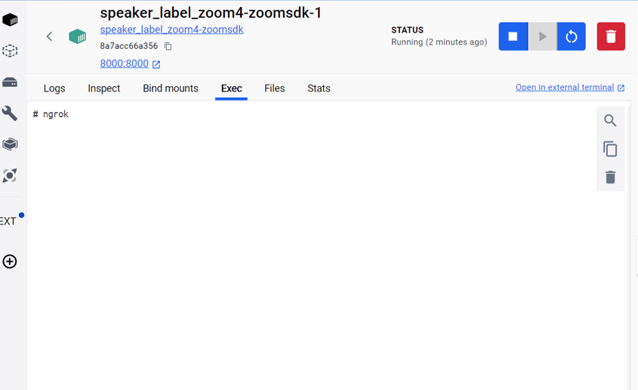

Go to the name of docker for zoom bot. here it’s speaker_label_zoom4-zoomsdk-1

There you go to Exec tab

Write command:

**ngrok http 8000**

after that command you will get one url like the following:

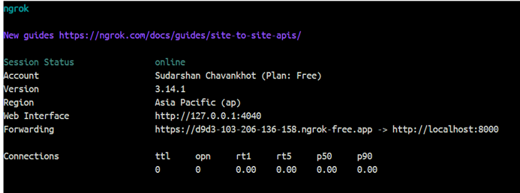

Copy this url:



Paste in postman

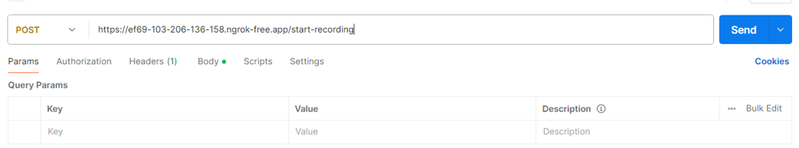

And click on send that will give status of start recording.

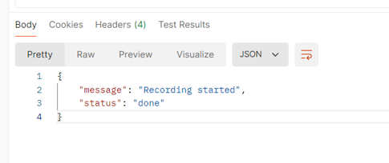

After that to see the log go to files tab and in tmp/out see the entry.log that shows recording started or not.

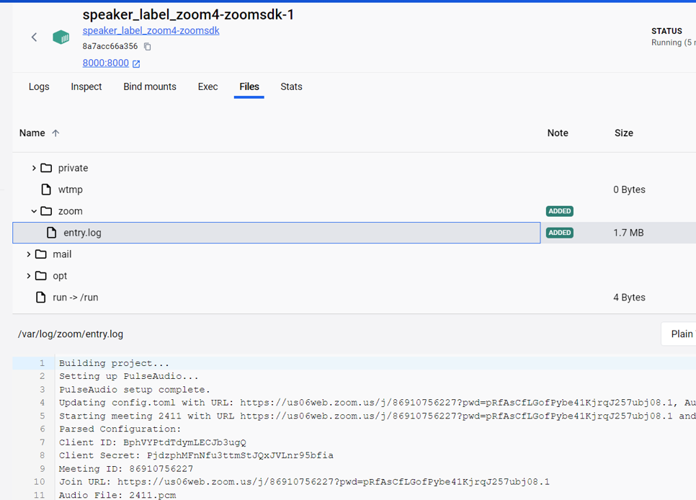

To check the details of timestamps

Go to postman and run this command with you meeting id

Here meeting id for ex., 2411.

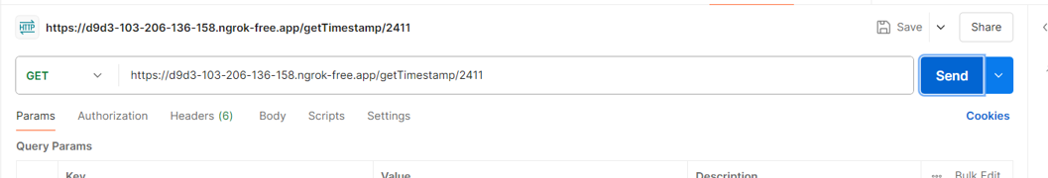

You will get transcript with timestamps.

Or else in tmp/{meeting_id}.txt is file will be there that shows the meeting

In tmp/out folder you can also see you recorded meeting. {.wav file}

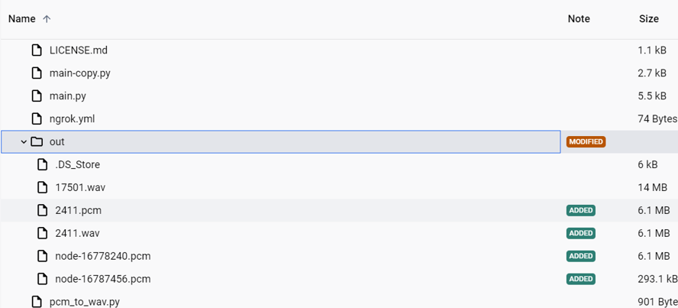

Problem we are facing for timestamps

<https://devforum.zoom.us/t/need-help-in-extracting-transcripts-from-the-audio-file/105560/3>

<https://developers.zoom.us/docs/api/rest/reference/zoom-api/methods/#operation/recordingGet>

<https://github.com/zoom/meetingsdk-linux-raw-recording-sample>

<https://devforum.zoom.us/t/get-time-when-each-participant-spoke-using-api/27873/6>

account access details

zoom

sudarshanchavankhot@gmail.com

password Gayu@1803

**HOW TO CREATE ZOOM BOT SDK?**

**References**

<https://www.youtube.com/watch?v=8SitD9mTXlA>

<https://github.com/zoom/meetingsdk-headless-linux-sample>

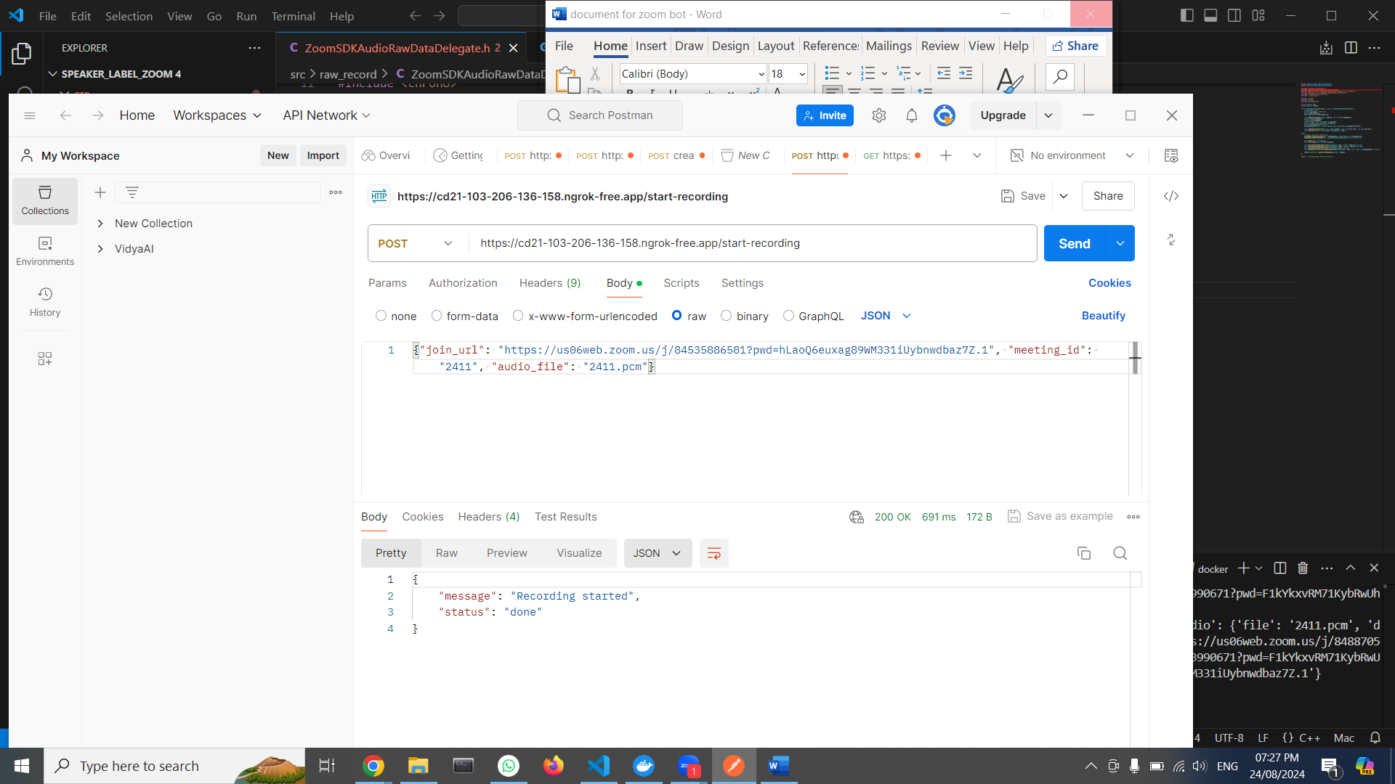

Here you have to change meeting id.

What is command to build on server?

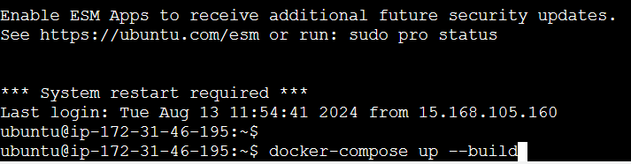

To change the client id and client secret

Go to config.toml file and change client-secret and client-id

To make zoom bot changes.

1 sudo docker-compose up --build

2 ls

3 cd out/

4 ls

5 git add Dockerfile

6 cd ..

7 ls

8 git add Dockerfile

9 git commit -m "Replace old Dockerfile with the new one"

10 git push origin main

11 vi Dockerfile

12 cd ..

13 ls

14 rm -rf ultimeet-bot

15 ls

16 mkdir zoom-bot

17 ls

18 cd zoom-bot/

19 git clone https://github.com/sudarshan2410/ultimeet_bot.git

20 ls

21 cd ultimeet_bot/

22 sudo docker-compose up

23 sudo docker-compose down

24 sudo docker-compose up --build

25 cd lib/zoomsdk/

26 unzip libmeetingsdk.so.zip

27 ls

28 cd ..

29 sudo docker-compose down

30 sudo docker-compose up --build

31 docker-compose up --build -d

32 sudo docker-compose down

33 docker-compose up --build -d

34 sudo apt-get

35 sudo apt-get update

36 sudo apt-get upgarde

37 sudo apt-get install && upgrade

38 sudo apt-get upgrade

39 docker

40 sudo apt install docker.io

41 mkdir ultimeet-bot

42 ls

43 cd ultimeet-bot/

44 git clone https://github.com/sudarshan2410/ultimeet_bot.git

45 ls

46 cd ultimeet_bot/

47 ls

48 docker-compose up --build

49 sudo snap install docker

50 docker-compose up --build

51 sudo groupadd docker

52 sudo usermod -aG docker sudarshan

53 sudo systemctl restart docker

54 newgrp docker

55 sudo docker-compose up --build

56 sudo yum install unzip

57 sudo apt-get update

58 sudo apt-get install unzip

59 ls

60 cd lib

61 ls

62 cd zoomsdk/

63 ls

64 unzip libmeetingsdk.so.zip

65 ls

66 cd ..

67 ls

68 clear

69 docker-compose up --build

70 docker-compose up --build

71 sudo systemctl start docker

72 docker-compose up --build

73 sudo usermod -aG docker $USER

74 docker-compose up --build

75 newgrp docker

76 ls

77 cd zoom-bot/

78 cd ultimeet_bot/

79 https://ap-northeast-3.console.aws.amazon.com/ec2-instance-connect/ssh?connType=standard&instanceId=i

80 docker images

81 sudo vim test.py

82 ls

83 python test.py

84 python3 test.py

85 pip install pyaudiowpatch

86 pip install pyaudio

87 sudo pip install pyaudio

88 sudo apt install python3-pip

89 python3 test.py

90 python3 -m venv testgmeet

91 sudo python3 -m venv testgmeet

92 python3 test.py

93 sudo python3 -m venv testgmeet

94 ls

95 cd zoom-bot/

96 ls

97 cd ultimeet_bot/

98 ls

99 vi main.py

100 cd src/

101 cd raw_record/

102 ls

103 vi ZoomSDKAudioRawDataDelegate.h

104 vi ZoomSDKAudioRawDataDelegate.cpp

105 cd ..

106 ls

107 docker-compose up --build -d

108 clear

109 docker-compose down

110 ls

111 vi main.py

112 docker-compose up --build -d

113 ls

114 vi main.py

115 ls

116 cd zoom-bot/

117 ls

118 cd ultimeet_bot/

119 ls

120 cat main.py

121 clear

122 ls

123 cd zoom-bot/

124 ls

125 cd ultimeet_bot/

126 ls

127 vi main.py

128 ls

129 cd src

130 ls

131 cd raw_record/

132 ls

133 vi ZoomSDKAudioRawDataDelegate.h

134 vi ZoomSDKAudioRawDataDelegate.cpp

135 cd ..

136 ls

137 docker-compose down

138 docker-compose up --build

139 cls

140 clear

141 ls

142 cd src

143 cd raw_record/

144 cd ..

145 vi main.py

146 docker-compose up --build

147 vi main.py

148 docker-compose up --build

149 docker-compose down

150 docker-compose up --build

151 vi main.py

152 docker-compose down

153 docker-compose up --build

154 clear

155 vi main.py

156 docker-compose down

157 vi main.py

158 docker-compose down

159 docker-compose up --build

160 docker-compose down

161 vi main.py

162 docker-compose down

163 docker-compose up --build

164 vi main.py

165 docker-compose down

166 docker-compose up --build

167 vi main.py

168 docker-compose down

169 docker-compose up --build

170 ls

171 cd zoom-bot/

172 ls

173 cd ultimeet_bot/

174 ls

175 vi main.py

176 docker-compose down

177 docker-compose up --build

178 ls

179 cd zoom-bot/

180 ls

181 cd ultimeet_bot/

182 ls

183 cd src/raw_record

184 ls

185 vi ZoomSDKAudioRawDataDelegate.cpp

186 history

**Suggested by Dhiraj**

Docker compose build

Docker compose up -d

/home/ubuntu/ultimeet_bot/zoom_bot/

/zoom-bot/ultimeet_bot